[1] CSA-1557 CLOUD COMPUTING LAB PRACTICALS

5.Create a Cloning of a VM and Test it by loading the Previous Version/Cloned VM.

Step-1:

First install VMware workstation on your pc/laptop. Then open the VM software and click create a new virtual machine displayed on a home tab.

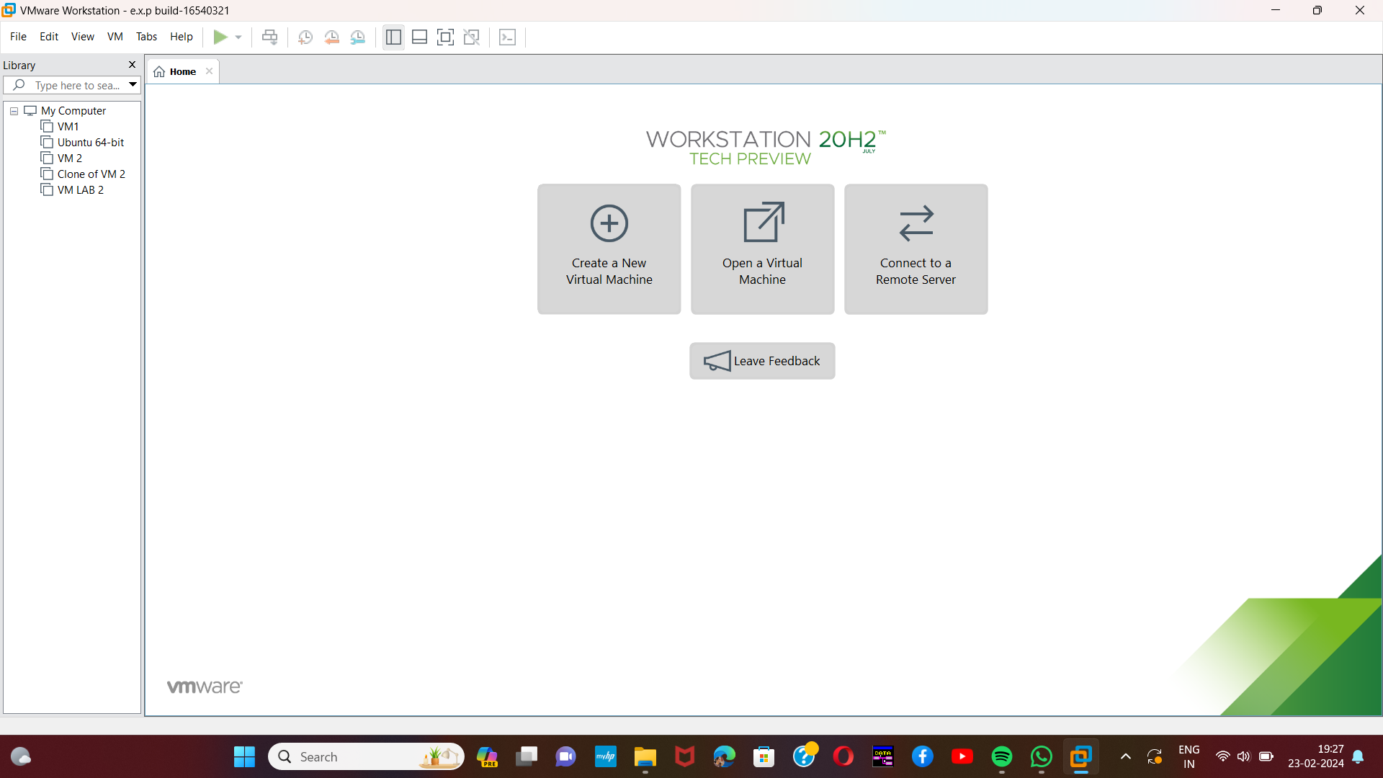

Step-2:

Then open any already created dummy Virtual Machine.

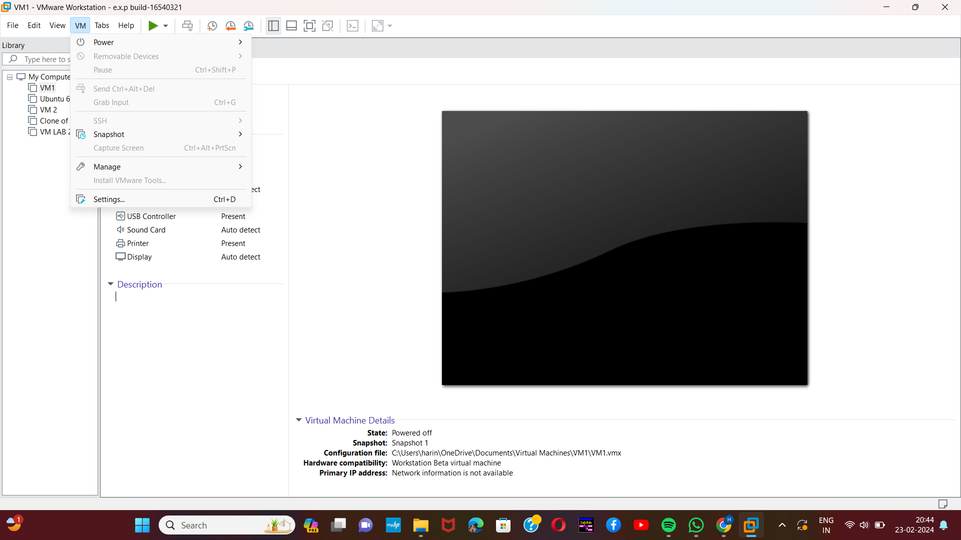[2]

Step-3:

In VM select manage option. In that click the clone option.

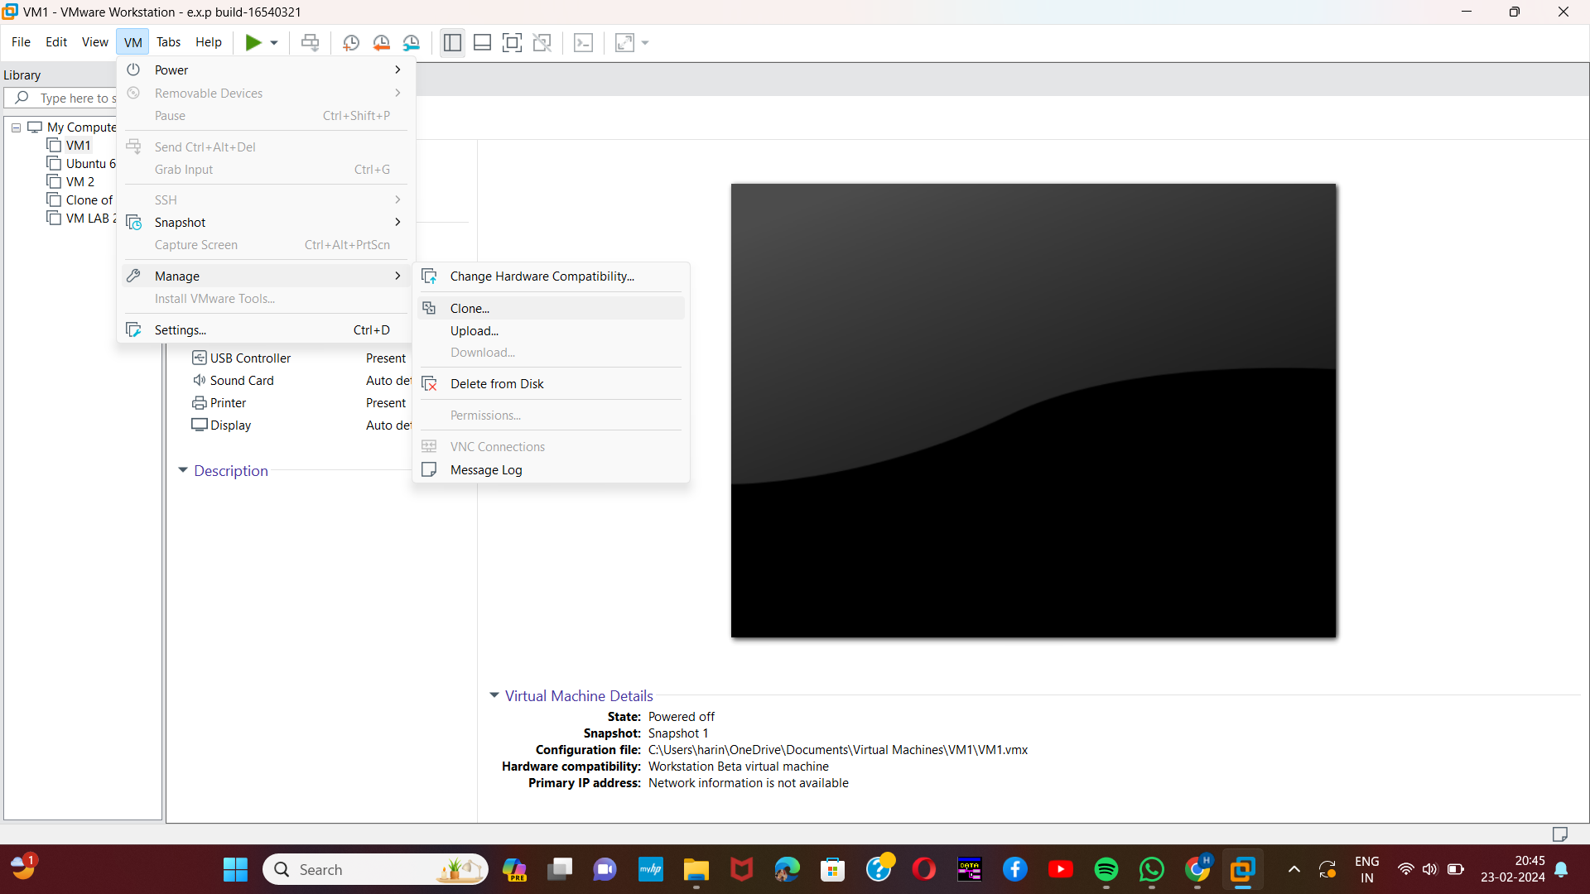

[3]Step-4:

Then a message will be displayed. In that select the first option which will be the current state in the VM.

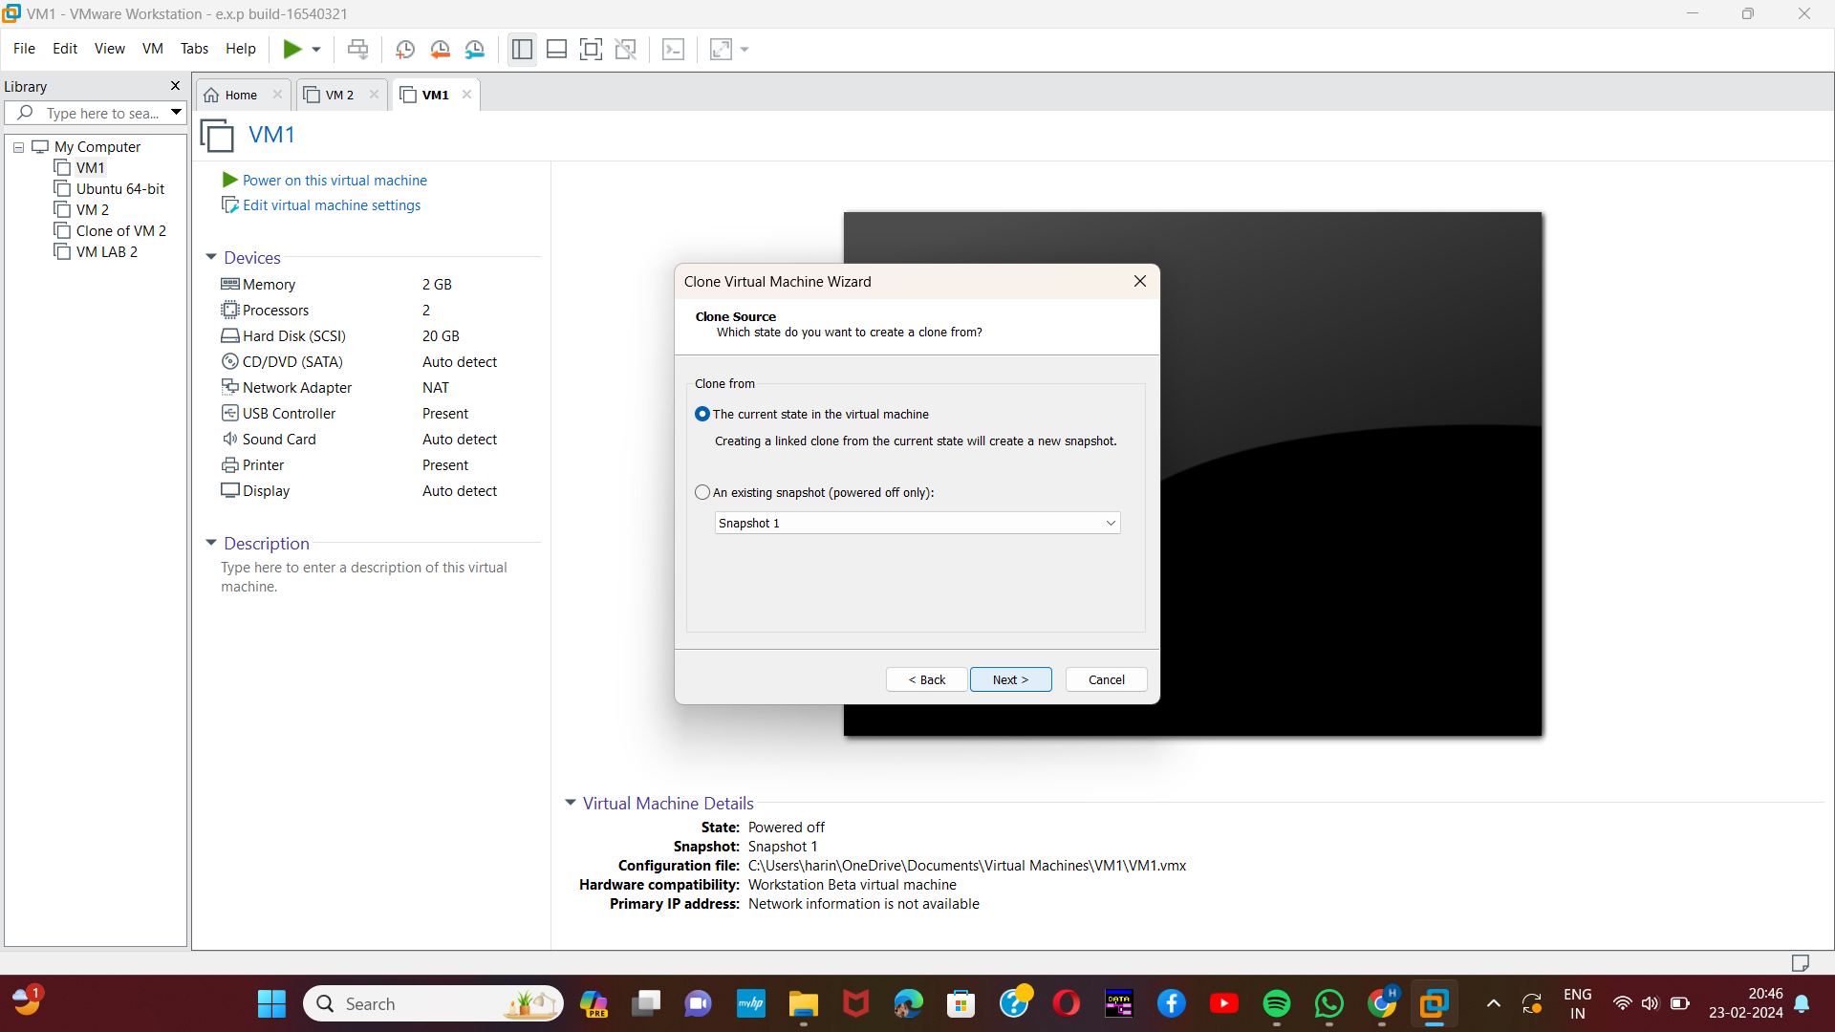

Step-5:

Then select create a full clone option.

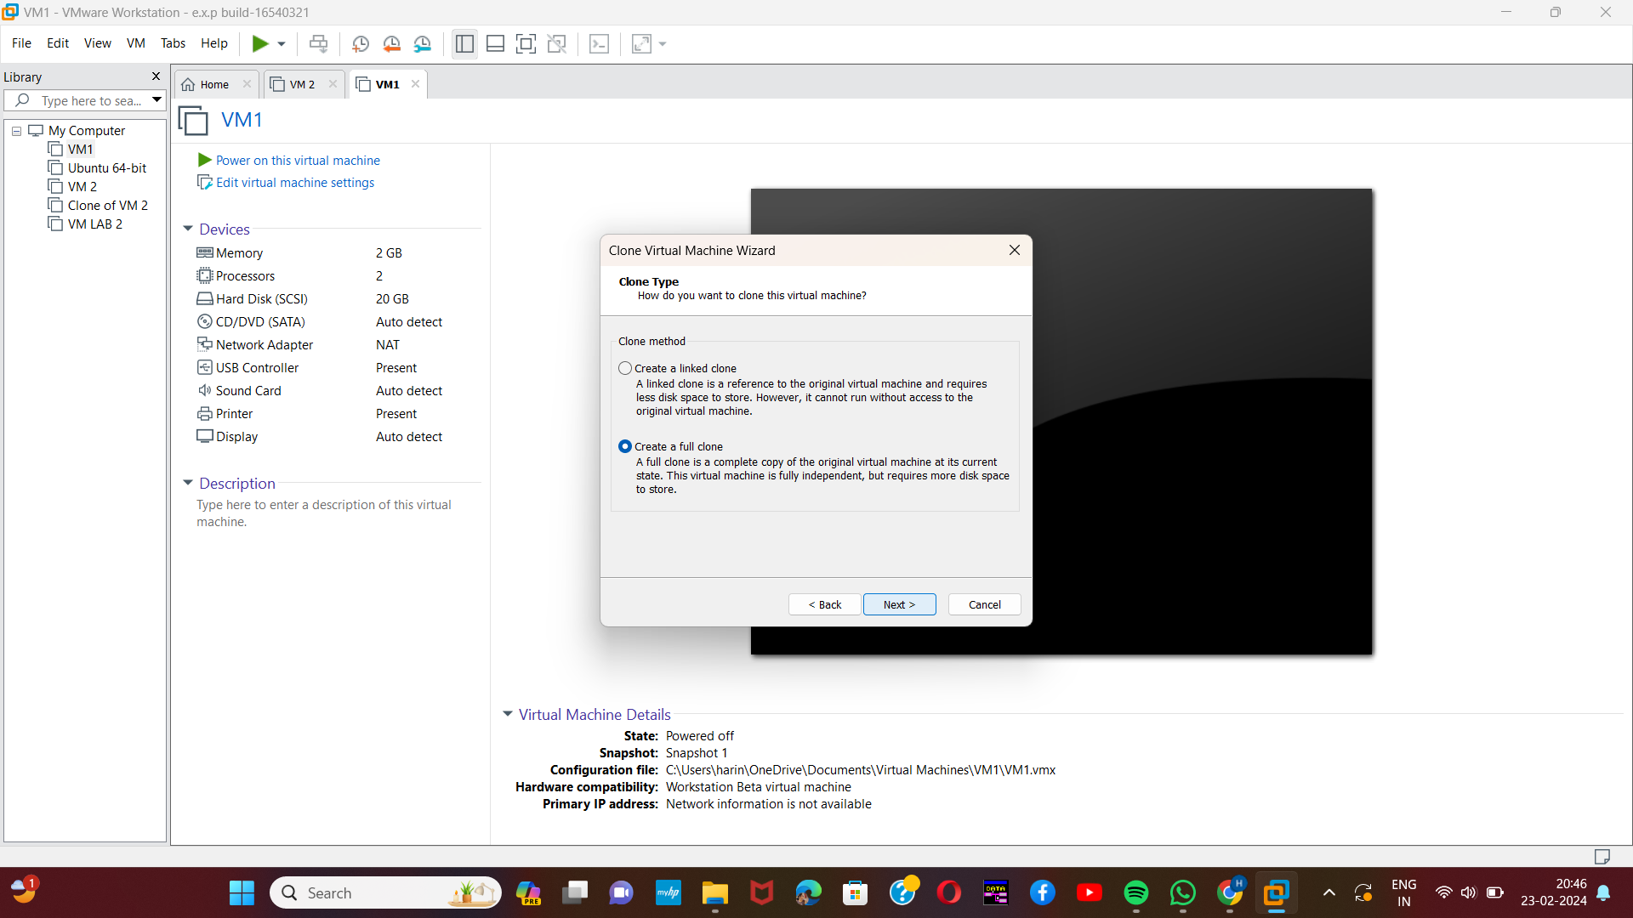

[4]Step-6:

Then we need to provide the name of the new cloned VM.and then click “finish”.

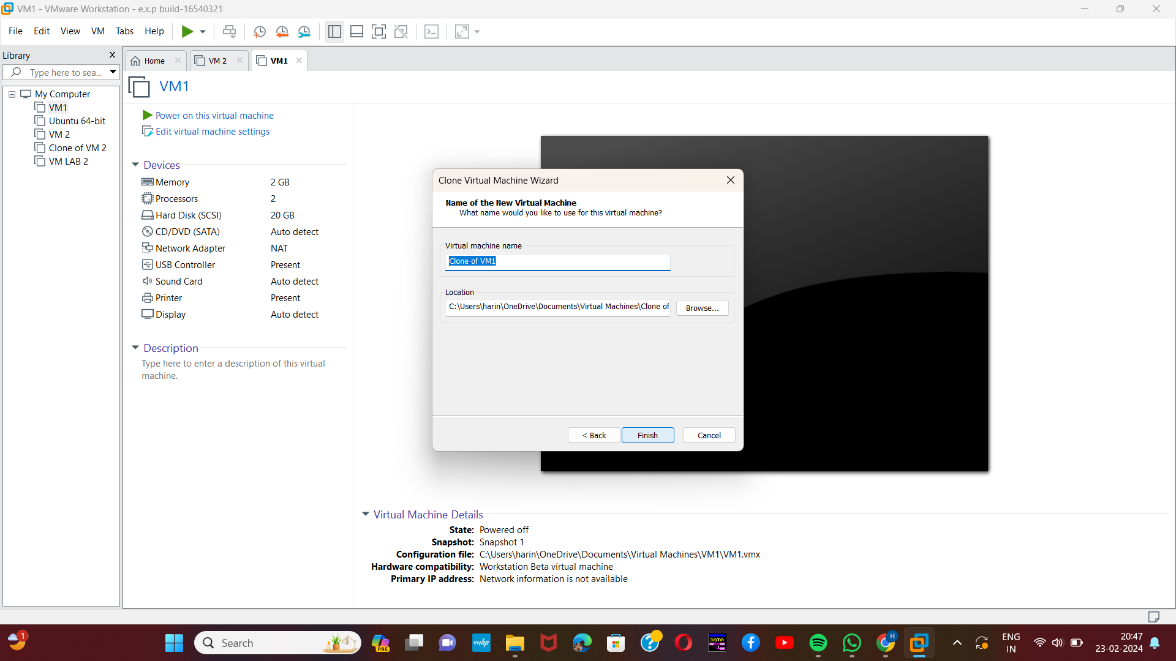

Step-7:

Then select the close option. The new clone of the selected VM will be created.

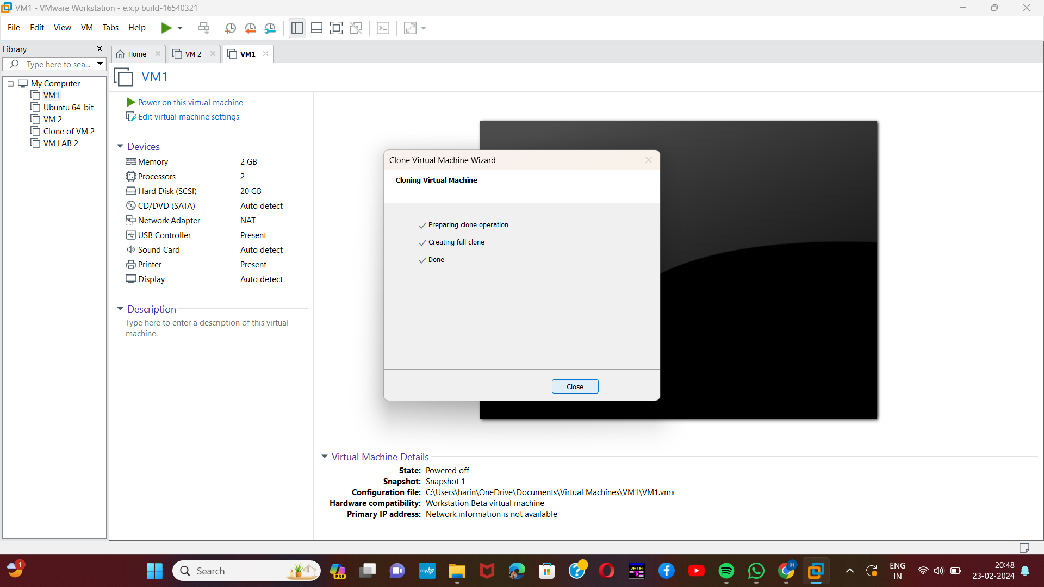

[5]

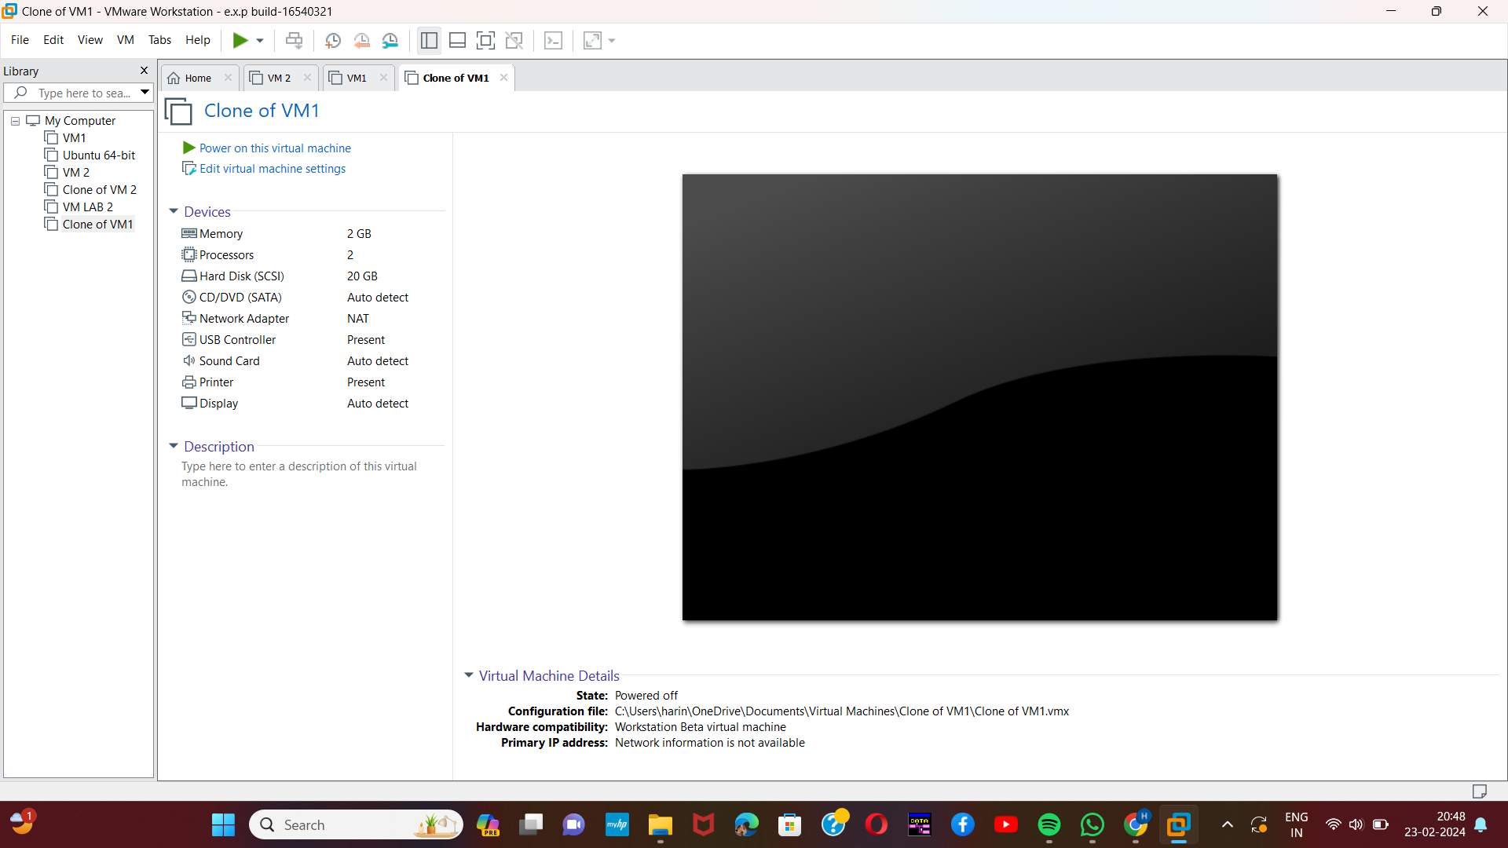

1. Harini 192221109
2. Harini 192221109
3. Harini 192221109
4. Harini 192221109
5. Harini 192221109